**Experiment 2:-**

Design an LED Chaser.

**Circuit Diagram:-**

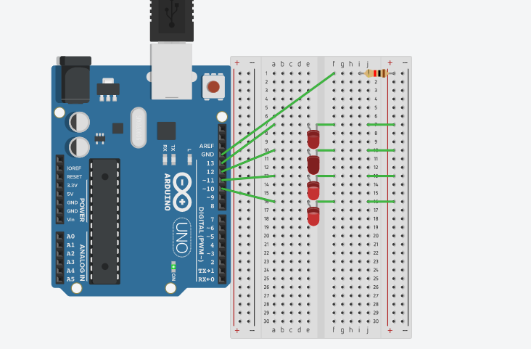

**Theory:-**

**Concept Used:-**

The concepts used in this experiment are:-

* The arduino board can supply a power of 5v as digital output signals through the 14 pins (namely 0-13) present in it as digital input or output pins.
* The GND pin of the arduino board acts as ground.
* In the bread board,the two rows present at the top and bottom each, are connected with each other in series and the columns are connected in a set of 5 each. The connection pattern is shown below: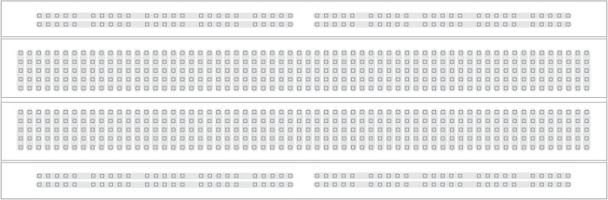
* In series circuit, voltage gets divided and in parallel circuit the current gets divided.
* Kirchoff’s current law:-Total current flowing through a junction is equal to current flowing out of the junction.
* Ohm’s Law:-Ohm’s law states that the current through a conductor is directly proportional to the voltage across the two points provided that the physical conditions such as temperature remains constant.

V=IR

Where V= voltage,

I=current

And R= resistance

**Learnings and Observations:-**

**Learnings:-**

* I have learned how to make a parallel circuit connection using an arduino board and a breadboard.
* I have learned how to make different patterns by using LED bulbs by giving different signals through arduino board.

**Observations:-**

* While doing this experiment, I had observed that first two LEDs glows and then the first LED goes off and the third one glows and a chain like this is formed and this pattern is a replication of the code that we have made for the arduino board to pass signals.

**Problems and Troubleshooting:-**

* The LEDs were not working condition.
* The ends of the wire were not getting inserted properly in the holes of the breadboard so I had to rub the ends with a sand paper.
* The arduino board was not working properly.
* The required pattern was not getting created because of some error in the code so I had to change the code as it was required.

**Precautions:-**

The precautions needed while doing this experiment are:-

* The wires are inserted properly and tightly at the required points.
* The two pins of the LED should be connected at their proper point that is the positive terminal should be connected with the p pin and the negative terminal should be connected with the n pin.

**Learning Outcomes:-**

* I have learned how to connect different hardware with an arduino board to form a parallel series.
* I have gained the skill of making different kind of patterns of light using LEDs and an arduino board.